

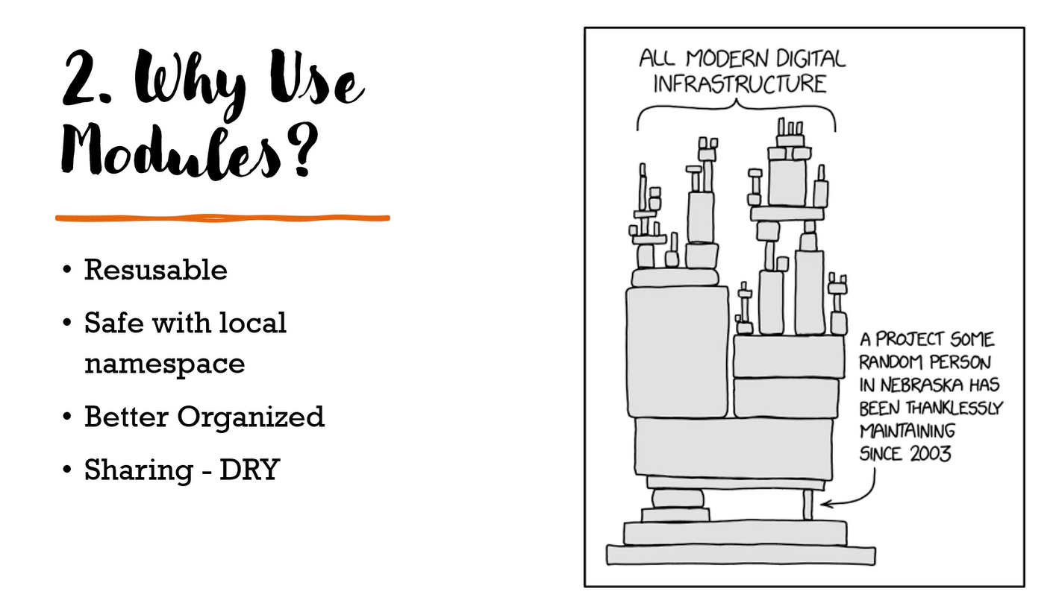

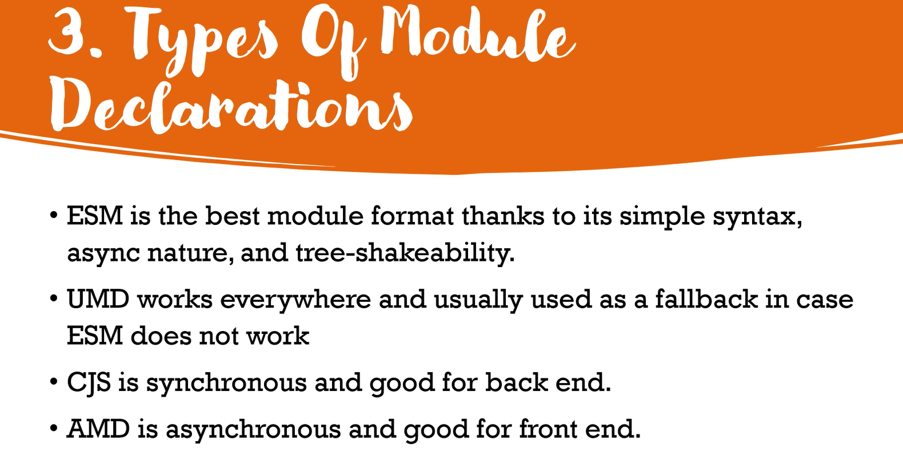

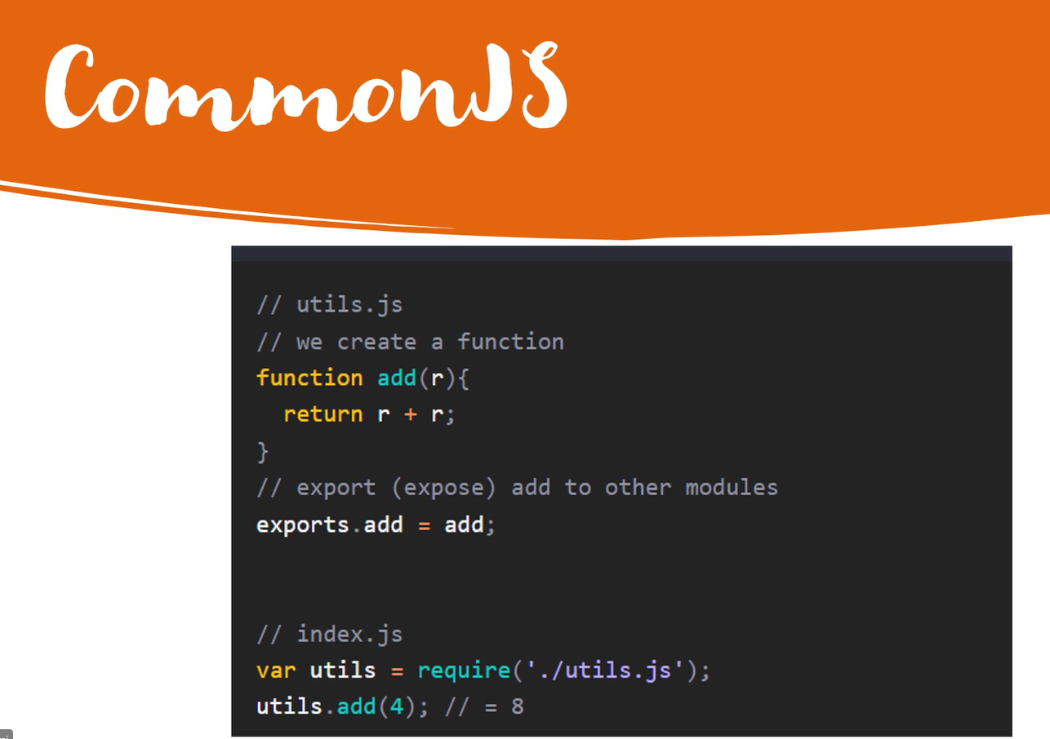

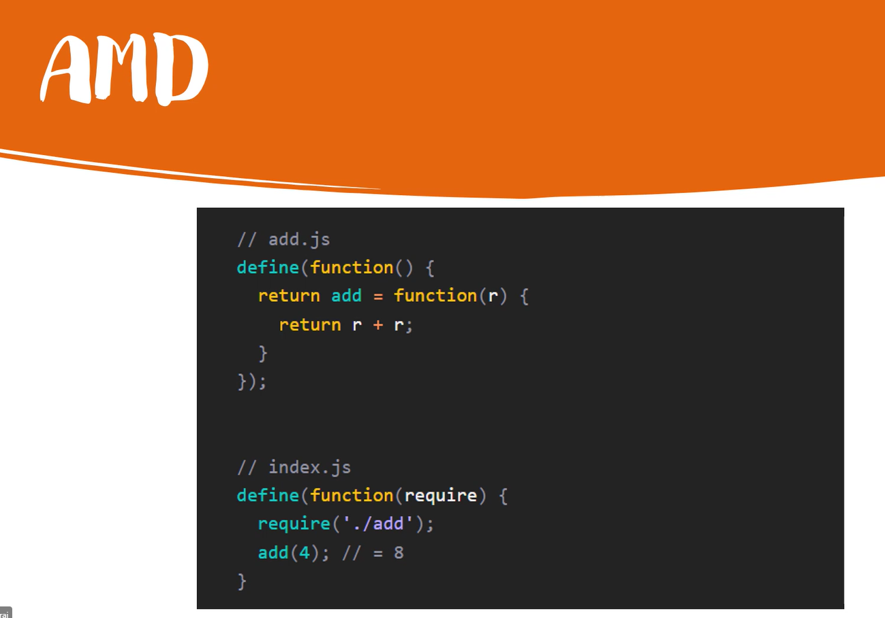

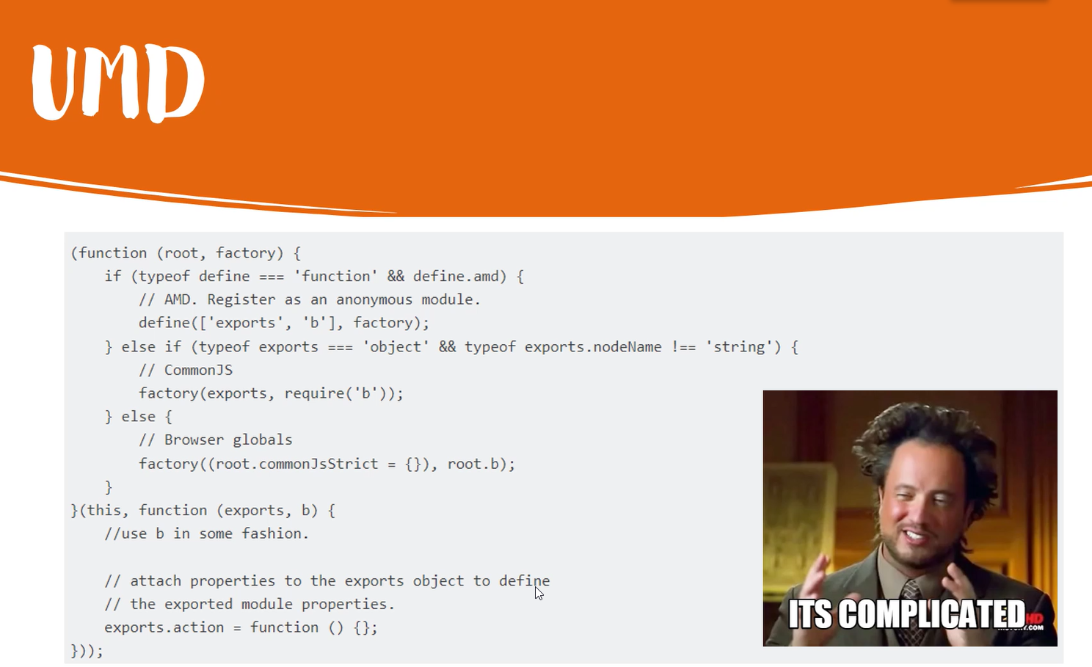

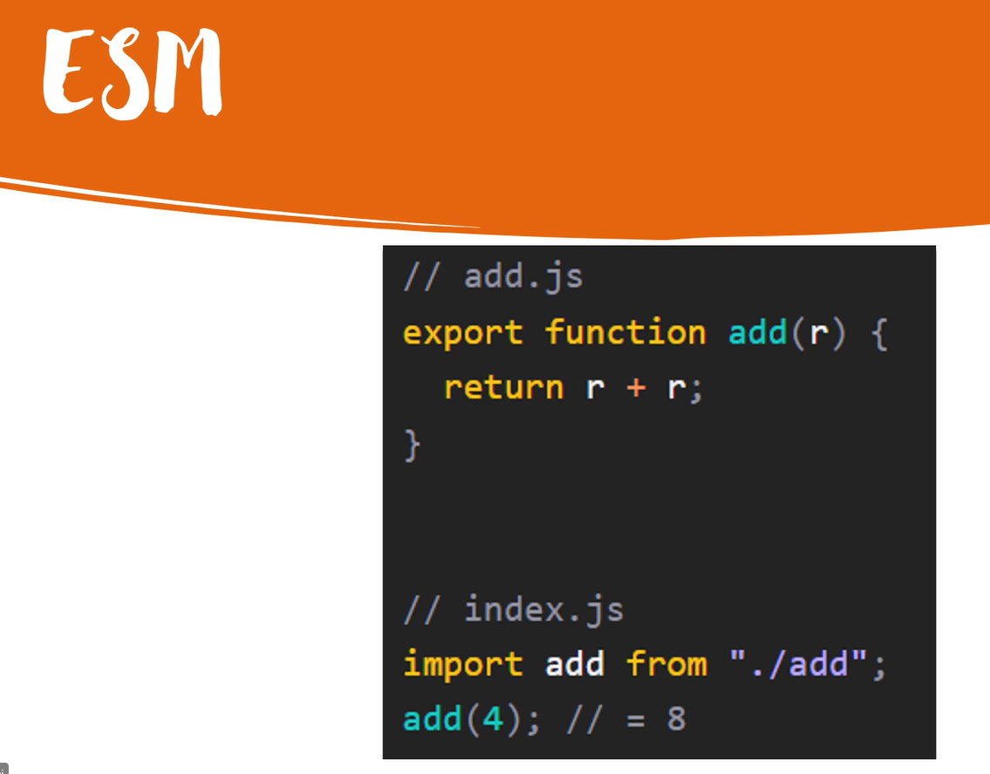

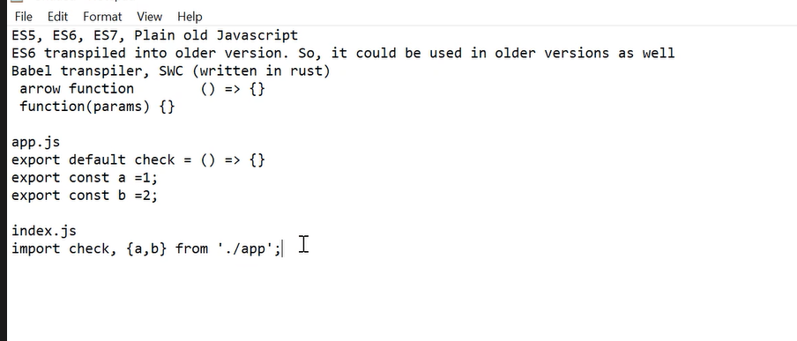

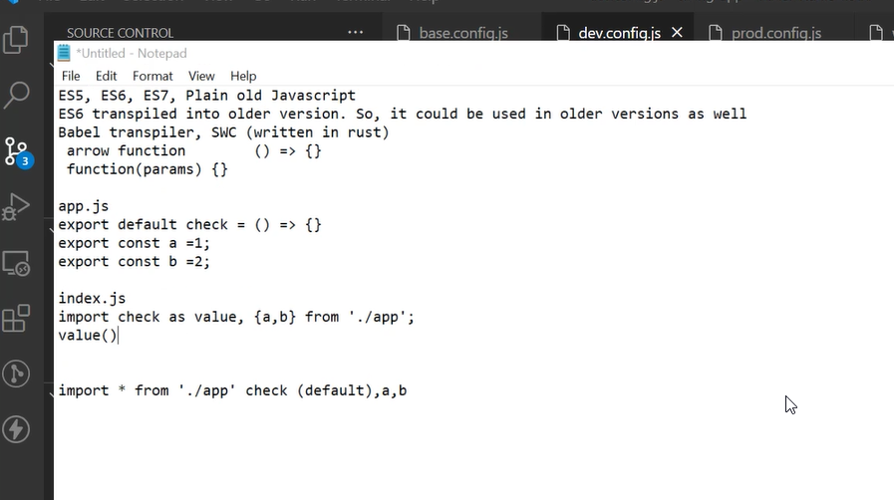

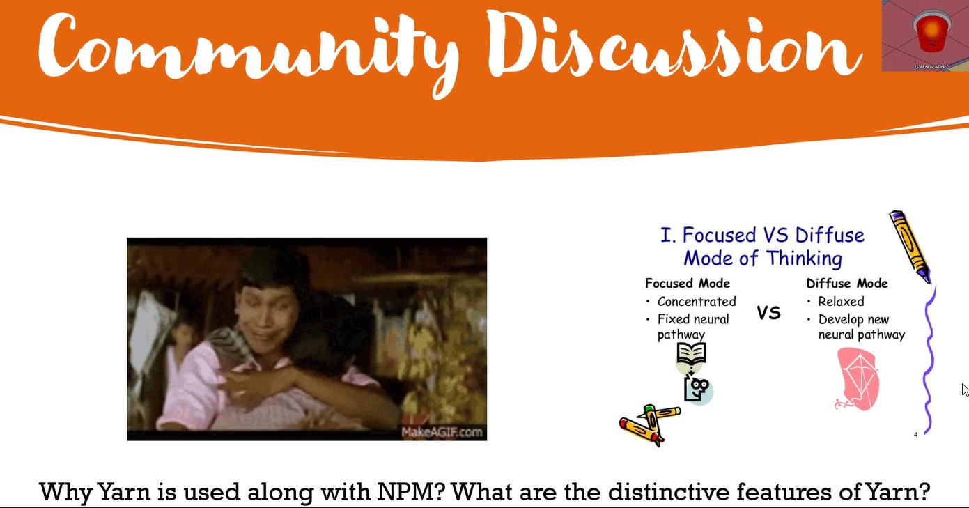

[16:21] Nithyanandam Venu

yarn had workspace which is design part of our monorepo setup.

<https://phoenixnap.com/kb/yarn-vs-npm#:~:text=Speed%20and%20Performance,files%20in%20the%20offline%20cache>. the way they install the packages is different which gives the advantage

yarn creates the dependency tree very fast, supports mono repo very well

<https://www.linkedin.com/posts/nithyanandam-venu-aa6ba576_monorepo-explained-activity-6947439805186080768-IzoG?utm_source=linkedin_share&utm_medium=member_desktop_web> Credit to Nithyanandam Venu

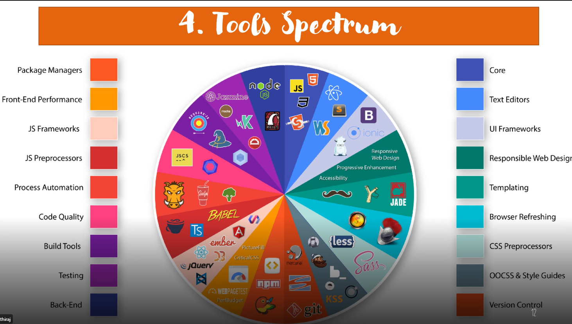



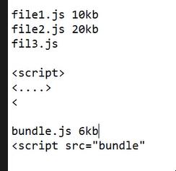

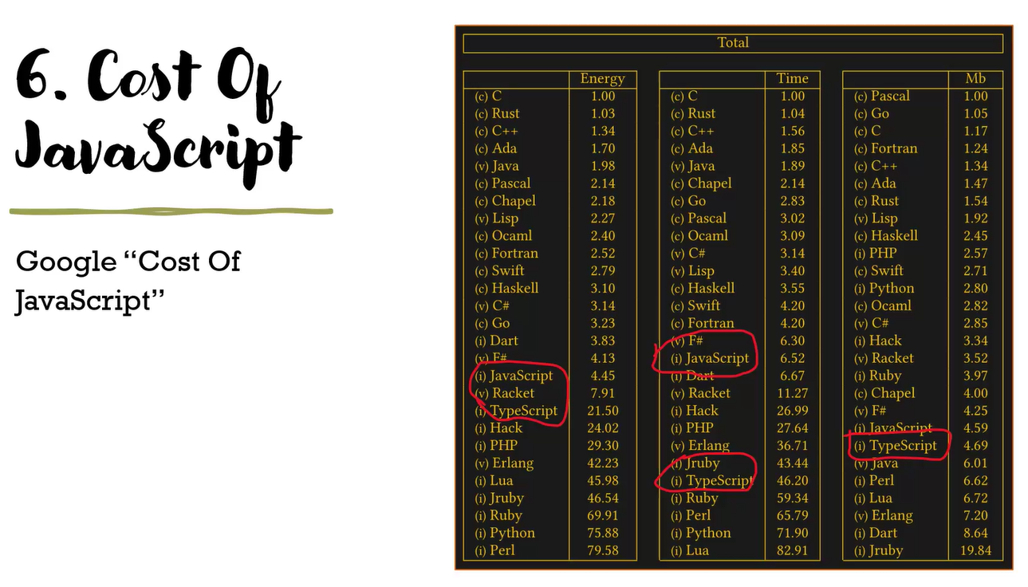

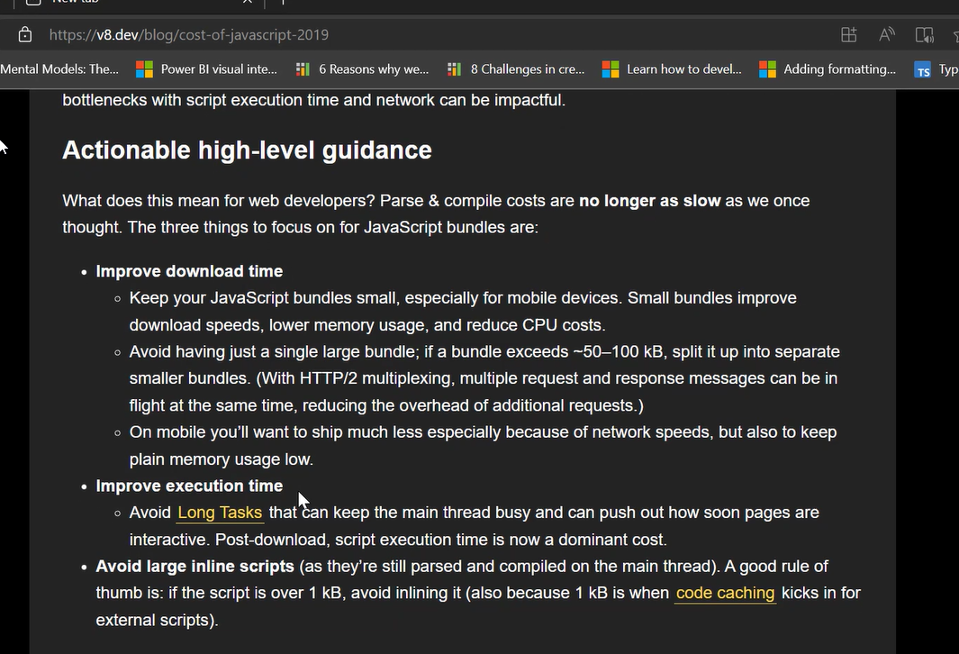

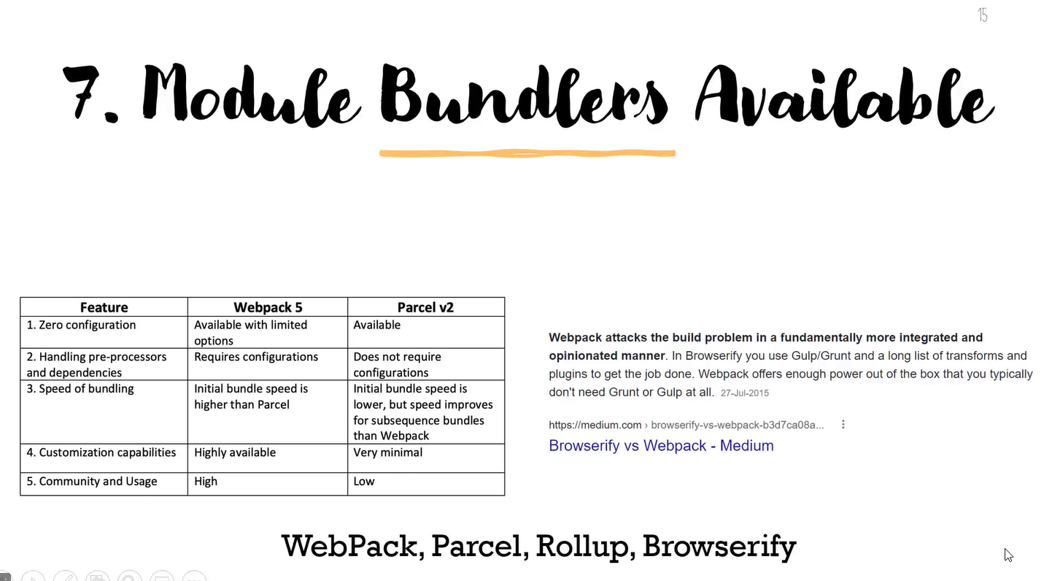

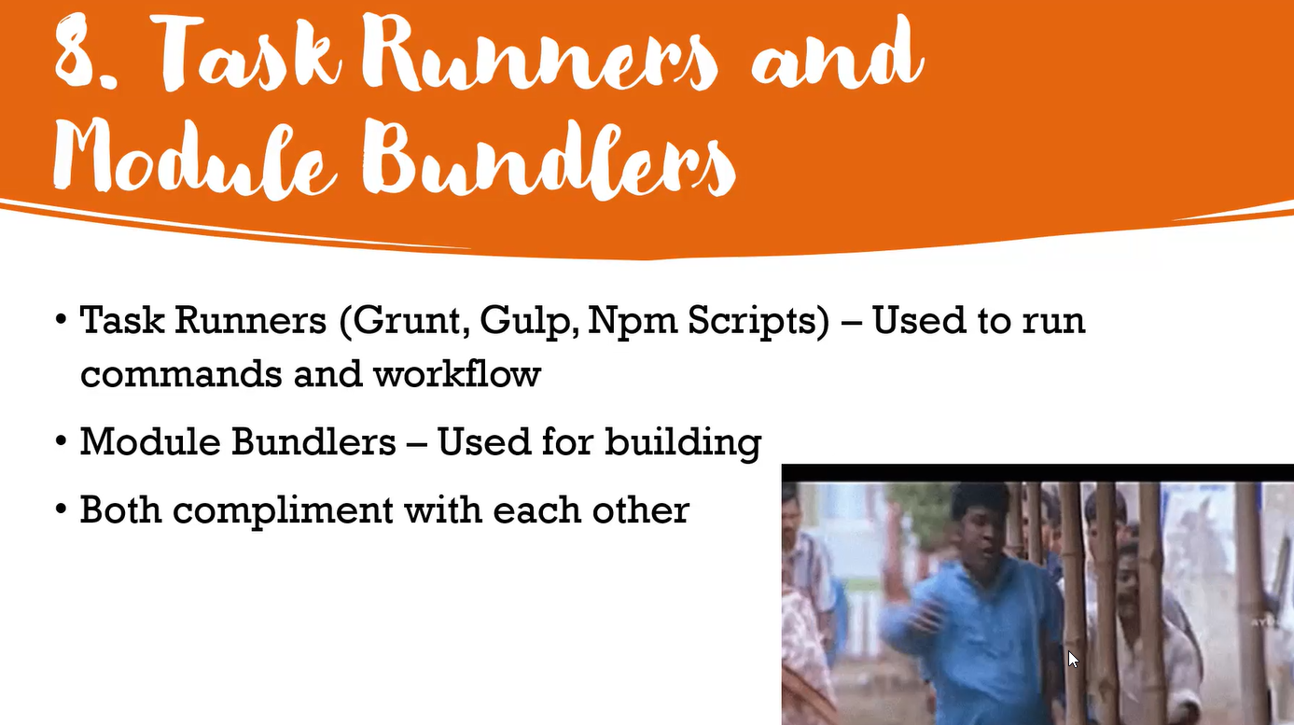

[16:35] Habeebur Rahman

gulp is npm scripts on steroids

[16:36] Nithyanandam Venu

fun fact <https://www.youtube.com/watch?v=gEBUU6QfVzk&t=865s> webpack almost 80% of the source code is made by its own plugins system  !!

Understanding webpack from the inside out - YouTube

webpack is a JavaScript module bundler that has taken the world by storm. This talk by a webpack maintainer covers webpack from the inside-out. You'll learn ...



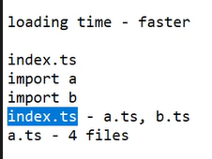

[16:44] Thayalan Ganesan Rajan

sample custom plugin - <https://github.com/SellerSpot/webpack-run-scripts-custom-plugin>

like 2

GitHub - SellerSpot/webpack-run-scripts-custom-plugin: webpack custom plugin which triggers command on successful emit of the files without errors and warnings.

webpack custom plugin which triggers command on successful emit of the files without errors and warnings. - GitHub - SellerSpot/webpack-run-scripts-custom-plugin: webpack custom plugin which trigge...



